
NAME : BISMA FATIMA
CLASS : CS A
ROLL NO: F24605036
COURSE : COMPUTER NETWORK
COURSE CODE : CS-271
LECTURER : SIR NAVEED YOUSAF

LAB 09
Configuration of DHCP

Warm up Task [30 Minutes]
- Answer each question in your own words (3 to 4 lines)
1. What is DHCP?
- Definition: DHCP stands for Dynamic Host Configuration Protocol.
- It is a network management protocol used to automatically assign IP addresses and other communication parameters (like subnet mask, default gateway, DNS servers) to devices on a network.
- Instead of manually configuring each device, DHCP automates the process.
2. Why is DHCP Important?
- Automation: Eliminates the need for manual IP configuration.
- Error Reduction: Prevents mistakes like duplicate IP addresses.
- Efficiency: Saves time for administrators managing large networks.
- Flexibility: Devices can join or leave the network seamlessly.
- Scalability: Essential for large enterprise networks with thousands of devices.
3. How Does DHCP Work?
The DHCP process follows four main steps (DORA cycle):
- Discover: The client broadcasts a DHCPDISCOVER message to find available servers.
- Offer: The DHCP server responds with a DHCPOFFER, suggesting an IP address and configuration.
- Request: The client replies with a DHCPREQUEST, accepting the offered configuration.
- Acknowledge: The server sends a DHCPACK, finalizing the lease and confirming the IP assignment.
4. What is a DHCP Lease?
- A DHCP lease is the temporary assignment of an IP address to a client device.
- The lease includes details like:
  - IP address
  - Subnet mask
  - Default gateway
  - DNS servers
- The lease has a time duration, after which it must be renewed or reassigned.
5. Explain the DHCP Lease Renewal Process
- Midpoint Renewal (T1): At 50% of the lease time, the client sends a DHCPREQUEST directly to the server to renew its lease.
- Secondary Renewal (T2): If no response, at 87.5% of the lease time, the client broadcasts a renewal request to any available DHCP server.
- Expiration: If no server responds before the lease expires, the client must restart the DORA process to obtain a new IP.

Task 1
By using Drag and drop draw topology diagram as Shown below and attach screenshot of each step.

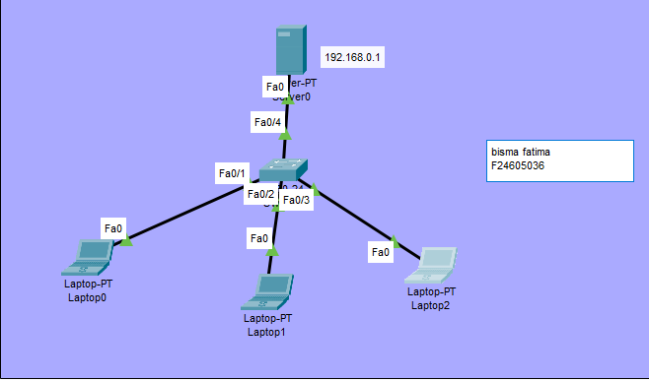
Figure 1. Packet Tracer Topology Diagram
SERVER IP ADDRESS
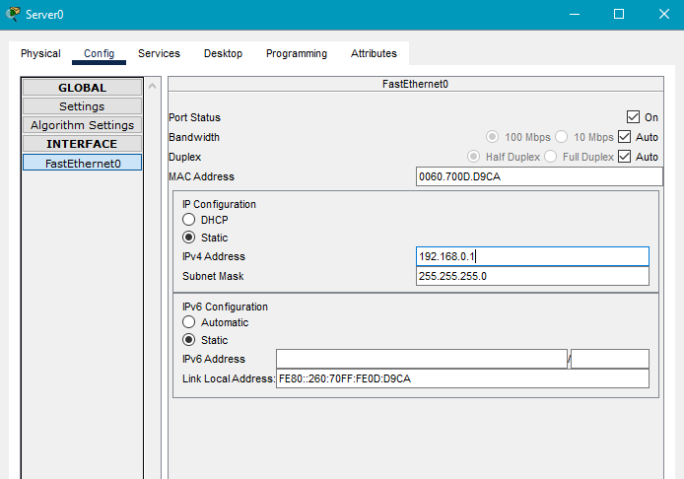
Server DHCP
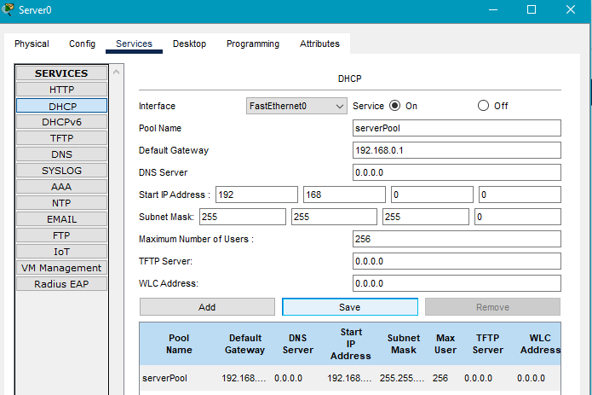
LAPTOP IP CONFIG DHCP
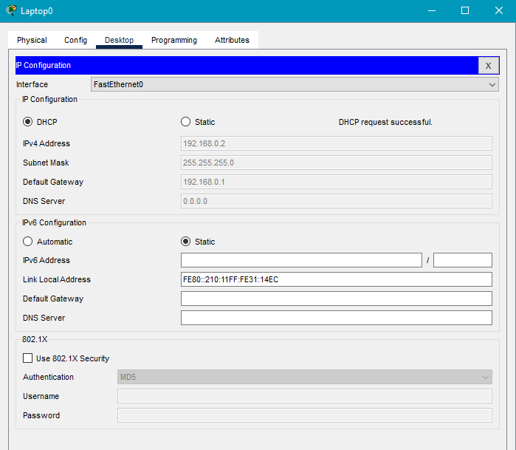
LAPTOP 02
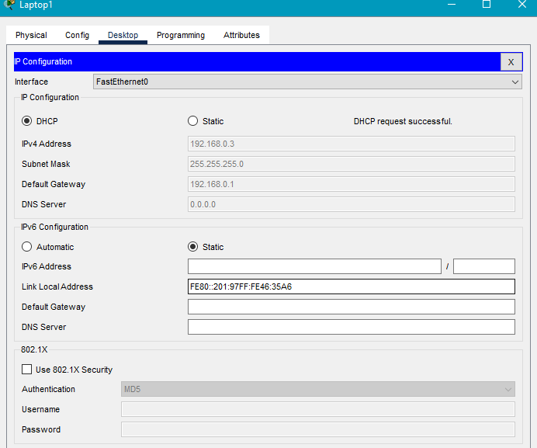
Laptop 03 ip config using DHCP
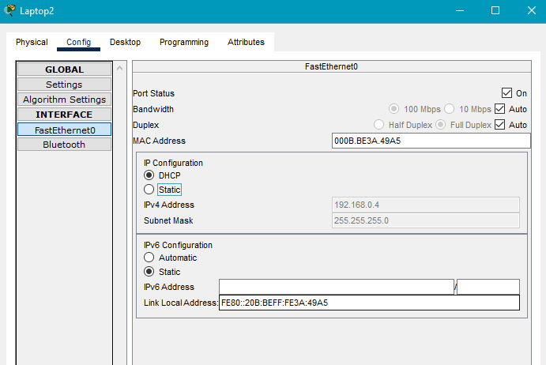
REAL time:
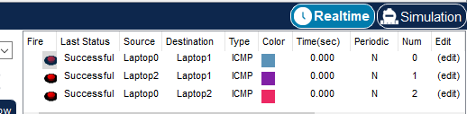

Task 2
By using Drag and drop draw topology diagram as Shown below and attach screenshot of each step.
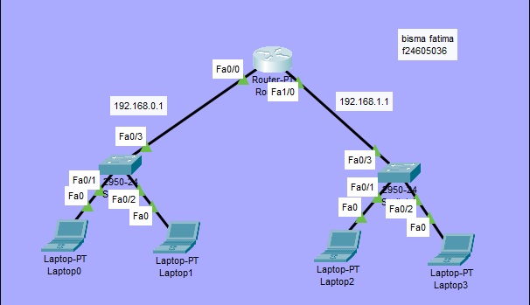
Figure 2. Packet Tracer Topology Diagram

Basic DHCP configuration Using Router
- Router>en
- Router#config t
- Router(config)#
- Router(config)#int fa0/0
- Router(config-if)#ip address 192.168.0.1 255.255.255.0
- Router(config-if)#no shut
- Router(config-if)#do write memory (Save information in memory)
- Router(config-if)#ip dhcp pool net1
- Router(dhcp-config)#network 192.168.0.0 255.255.255.0
- Default-router 192.168.0.1
- Exit
Network 01 config:
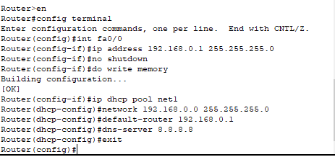
Repeat these Steps for Second network
- Net2 (192.168.1.0)
Network 02 config:

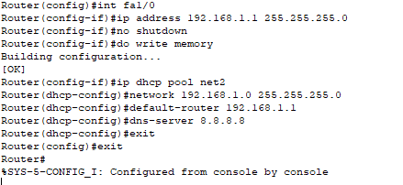
Laptop 00 dhcp config:
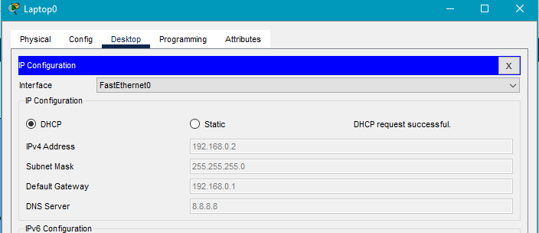
Laptop 01 dhcp config:
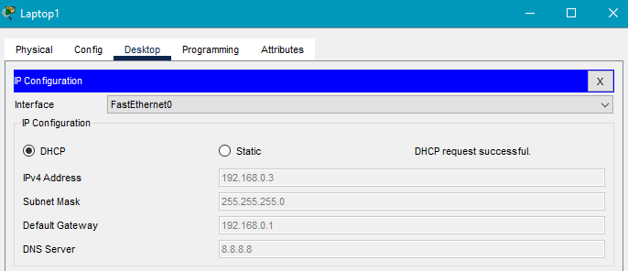
Laptop 02 dhcp config:
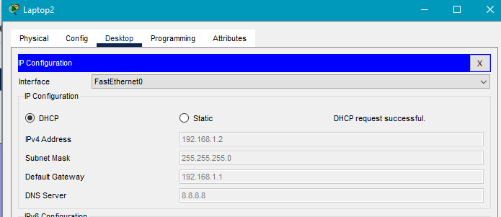
Laptop 03 dhcp config:
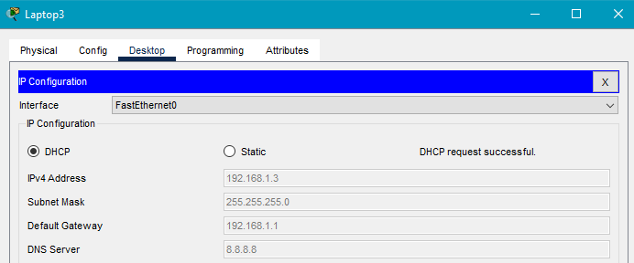

Real time :
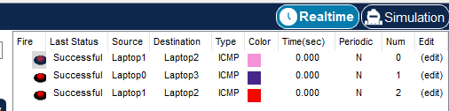

Task 3
You are tasked with setting up a network infrastructure using Cisco Packet Tracer. The goal is to implement DHCP services through Two routers and name each network with your own name example network 1 (dhcp pool abc1) and network 2(dhcp pool abc2)
1. Topology Setup
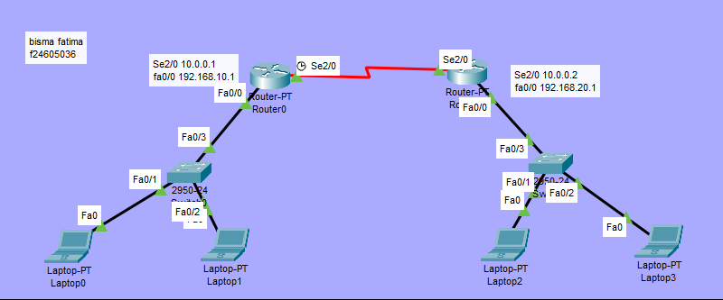
2. Configure Router Interfaces
On each router, assign IP addresses to interfaces:
Router0
- Router> enable
- Router# configure terminal
- Router(config)# interface fastEthernet 0/0
- Router(config-if)# ip address 192.168.10.1 255.255.255.0
- Router(config-if)# no shutdown
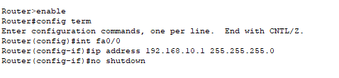
Router1
- Router> enable
- Router# configure terminal
- Router(config)# interface fastEthernet 0/0
- Router(config-if)# ip address 192.168.20.1 255.255.255.0
- Router(config-if)# no shutdown
- Router(config)# interface se2/0
- Router(config-if)# ip address 10.0.0.2 255.0.0.0
- Router(config-if)# no shutdown

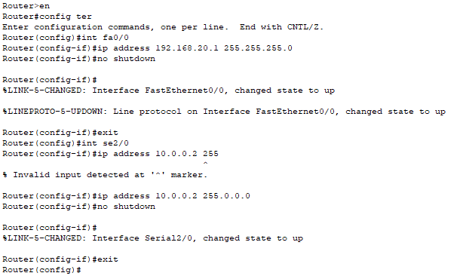
3. Configure DHCP Pools
Each router will act as a DHCP server for its local network.
Router0 DHCP (Pool bisma1)
- Router(config)# ip dhcp pool bisma1
- Router(dhcp-config)# network 192.168.10.0 255.255.255.0
- Router(dhcp-config)# default-router 192.168.10.1
- Router(dhcp-config)# exit
- Router(config)# ip dhcp excluded-address 192.168.10.1 192.168.10.10

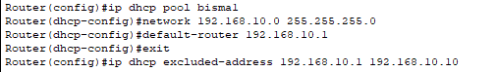

Router1 DHCP (Pool bisma2)
- Router(config)# ip dhcp pool bisma2
- Router(dhcp-config)# network 192.168.20.0 255.255.255.0
- Router(dhcp-config)# default-router 192.168.20.1
- Router(dhcp-config)# dns-server 8.8.8.8
- Router(dhcp-config)# exit
- Router(config)# ip dhcp excluded-address 192.168.20.1 192.168.20.10
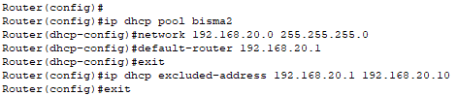
4. Connect Routers
Router0
- Router0(config)# router rip
- Router0(config-router)# version 2
- Router0(config-router)# network 192.168.10.0
- Router0(config-router)# network 10.0.0.0
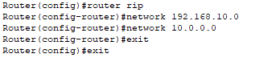
Router1
- Router1(config)# router rip
- Router1(config-router)# version 2
- Router1(config-router)# network 192.168.20.0
- Router1(config-router)# network 10.0.0.0
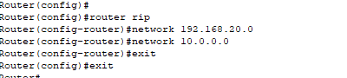
5. Test DHCP
Laptop0
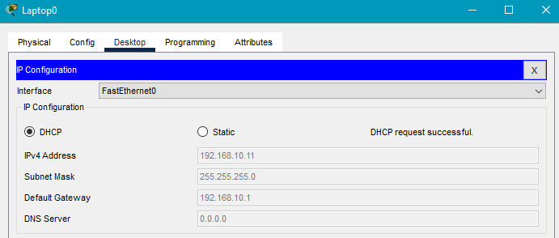

Laptop1
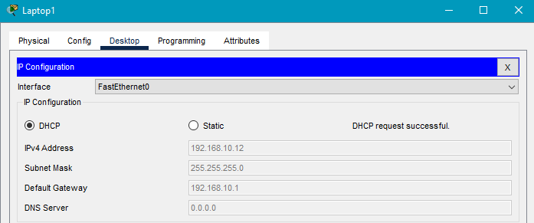
Laptop2
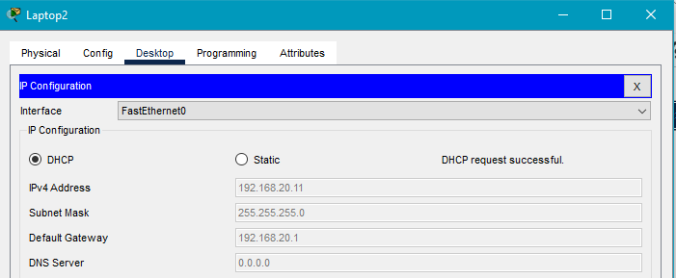
Laptop3
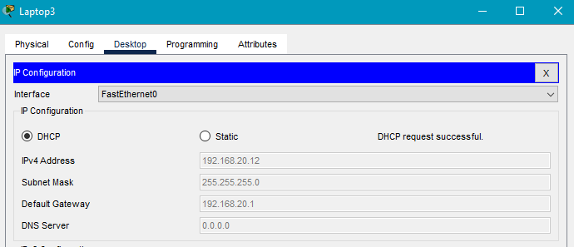
Real time:


